Secondary Storage

Secondary memory is the memory used in a system to store large amounts of data at a reduced cost. Furthermore, secondary memory is not cleared on shutdown of a machine. By contrast, every time a system shuts down, RAM as well as system caches are cleared. RAM is used to store smaller amounts of data, however, RAM is up to 6 times faster than the fastest secondary memory available on the market currently. The two primary types of storage on the market today are platter drives and solid-state drives (Stallings, William).

Traditional platter hard drives work by using a head to read magnetic signatures off of a spinning disk or platter. The CPU tells the hard drive what to find and the head of the hard disk drive searches for the given data and returns it to the CPU in a process known as reading. When creating a new file, the CPU is given the information and the hard drive stores the data as quickly as possible, and often times non-sequentially in a process known as writing. The fact that hard drives do not necessarily store data sequentially means that read time can be slowed considerably, causing functions such as defragmentation to be used. Defragmentation takes non-sequential data and places it close together on the disk, which shortens read operations considerably (Jongmin Gim).

Platter Based Hard Drive

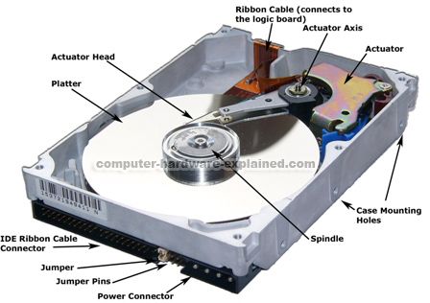

http://www.oocities.org/ubshreenath/upworkshop1.htm

This is a basic diagram of a platter hard drive, illustrating how the basic hard drive works. The key components discussed in this program are the actuator head and the platter.

Solid state drives work using a series of transistors in a formations of rows and columns, similar to a grid, to represent the data being stored. Each transistor represents a 1 or a 0, and all transistors are initialized at 1. A read operation simply looks at given segment of transistors in the grid and interprets the binary data. When a write operation is called, the CPU gives the data to the solid-state drive and the data is then stored in binary form at an available segment of transistors. An important factor to note is that solid-state drives do not need to be defragmented (in fact, defragmentation will lead to faster drive degradation, as it will cause unnecessary writes, a topic which will be covered later), as each transistor can be accessed directly, making data proximity irrelevant (Chun-Chieh Kuo).

Solid State Disk

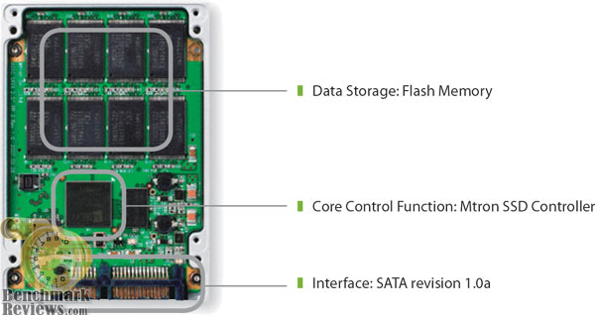

<http://archive.benchmarkreviews.com/images/reviews/storage/MSD-SATA3025/Mtron_MOBI_MSD-SATA3025_06.jpg>

This is a basic illustration of a solid-state drive. The flash memory is the key component discussed. This diagram also illustrates the processor used by the drive to process incoming and outgoing data.

One advantage of platter drives is cost. The price per gigabyte on a modern disk drive is around $0.05. By contrast, the cheapest solid state drives cost $0.60 per gigabyte, however, it should be noted that with the growing demand for solid state drives, the cost to produce such drives continues to drop as solid state drives become produced in greater volume. The cost advantage of platter drives at the moment makes them ideal for the use of backing up data from a large system. Solid state drives, however, are more useful when dealing with personal computing or computing on a server, as they allow for faster read and write time. This is due to the fact that solid state drives have the ability to access a given part of memory directly, where as a platter drive must search with the head sequentially until the requested piece of data is located (www.newegg.com).

Device longevity is another factor to take into account when dealing with various different types of secondary storage. The average lifespan of a disk-based hard drive ranges from five to seven years, depending on usage. However, there are other reasons for platter drives to fail, one such reason being movement or vibration. Such occurrences can cause the head of the reader to scratch a platter leading to a loss of data and often drive failure. By contrast, solid-state drives will not fail due to vibration or movement due to the fact that they have no moving parts. Furthermore, solid-state drives are rated for their longevity in hours by a factor called mean time between failures or MBTF. Many solid state drives are rated for over 1,000,000 hours of usage, which equates to over 100 years, however, the amount of up time is rarely what kills a solid state drive, the number of writes is often the limiting factor. Each segment of a solid state drive can only be written to a limited number of times, after that, a given segment cannot be written to again; that being said, these sectors can still be read from, meaning that drive failure does not necessarily lead to loss of data. Additionally, solid state drives support functions such as TRIM and AHCI, both of which are used to ensure that a given segment of a solid-state drive is not being repetitively written to, causing the drive to lose the ability to write to the aforementioned section (Dong Kim).

Currently, many personal computers are switching over to solid-state drives. There are several reasons behind this change, one of the primary reasons being the speed of a solid-state drive. Currently, a solid-state drive can read and write at speeds near three gigabytes per second, assuming a desktop is being used in conjunction with a PCIe solid-state drive. Such speeds are a vast improvement over the platter drives which often max out at 200 megabytes per second. Drives with speeds such as these are ideal for servers, which have to deal with massive amounts of incoming and outgoing data simultaneously. On the consumer side of solid state disks, speeds are limited in a majority of Windows computers due to the SATA standard, which can currently only deal with 600 megabytes per second. Mac computers have a different standard for their solid state drives, the current Mac Pro is offering up to 1.35 gigabytes per second, a feat accomplished by using PCIe connectors to handle data transfer as opposed to SATA. Mac laptops are also offering faster read and write speeds than SATA, namely the Retina MacBook Pro as well as the MacBook Air, both offering over 750 megabytes per second of data transfer. The speed of these drives is not the only reason that solid-state is used. Solid-state drives also consume considerably less power than a traditional disk drive, extending the life of mobile devices (www.newegg.com).

Solid-state drive are most likely the future of computing, they offer much faster speeds and a rapidly approaching the cost effectiveness of platter based hard drives. Additionally, the storage market is constantly trying to keep up with the market for processors, as not even the current RAM standard is fast enough to keep up the current generation of processors. Furthermore, the durability of solid state drives makes them much more desirable than disk drives, which can fail if impacted. Finally, the trend in the computer market currently is for thinner and thinner computers, solid state drives allow for one of the biggest part of a system to be shrunken down, removing off millimeters as well as pounds on a portable computer.

Bibliography:

Chun-Chieh Kuo; Jen-Wei Hsieh; Li-Pin Chang, "Detecting Solid-State Disk Geometry for Write Pattern Optimization," *Embedded and Real-Time Computing Systems and Applications (RTCSA), 2011 IEEE 17th International Conference on* , vol.2, no., pp.89,94, 28-31 Aug. 2011

Dong Kim; Kwanhu Bang; Seung-Hwan Ha; Sungroh Yoon; Eui-Young Chung, "Architecture Exploration of High-Performance PCs with a Solid-State Disk," *Computers, IEEE Transactions on* , vol.59, no.7, pp.878,890, July 2010

<http://archive.benchmarkreviews.com/images/reviews/storage/MSD-SATA3025/Mtron_MOBI_MSD-SATA3025_06.jpg>

http://www.oocities.org/ubshreenath/upworkshop1.htm

Jongmin Gim; Youjip Won; Jaehyeok Chang; Junseok Shim; Youngseon Park, "DIG: Rapid Characterization of Modern Hard Disk Drive and Its Performance Implication," *Storage Network Architecture and Parallel I/Os, 2008. SNAPI '08. Fifth IEEE International Workshop on* , vol., no., pp.74,83, 22-22 Sept. 2008

Stallings, William. *Computer Organization and Architecture: Designing for* *Performance*. Nineth ed. N.p.: Prentice Hall, 2013. Print.

www.wikipedia.org

www.newegg.com